Classification of KDDCup dataset using SVM Algorithm with Elastic reguliazer

Chapter1 : Introduction

1.1 Problem statement:

Classification of KDDCup dataset using SVM with Elastic reguliazer.

1.2 Overview of the project

* Support Vector Machine (SVM) is a very well known tool for classification and regression problems.
* Many applications require SVMs with non-linear kernels for accurate classification. Training time complexity for SVMs with non-linear kernels is typically quadratic in the size of the training dataset.
* In this project we depart from the very well-known variation of SVM, the so-called Support Vector Machine, and apply optimization technique/algorithm with elastic reguliazers for KDDCup dataset to enhance the scalability and time complexity of the algorithm in distributed setting.

1.3 Objective :

* Increase the scalability performance of the algorithm for the large and benchmark dataset
* Enhance the time complexity of the model for large dataset.

Chapter 2: Proposed System

2.1 Proposed system:

The experiments on KDDCUP99 dataset using svm and elastic net regulizers Classification is done using SVM classifier. It gives the result either in “One” or “zero” results. During classification of attacks, any type of attack is classified properly to their belonging class then “One” result is displayed and accuracy of classification is increases as per the “Zero” result. If any type of attack is not classified to their belonging class means it appears in wrong class then the result shown “Zero”.

2.2 Block diagram

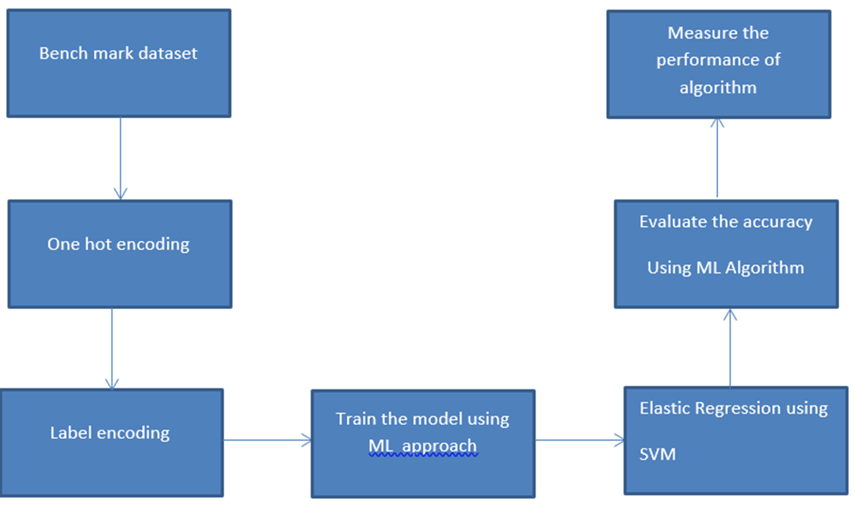

2.4 Scope

Our Project is classification KDDcup svm with elastic net regulazation

* Increase the scalability performance of the algorithm for the large dataset
* Enhances complexity of large dataset

Chapter 3: Software requirement specification

3.1 Overview of SRS

The introduction of the software requirement specification (SRS) provides an overview of the entire SRS with purpose, scope, definitions, acronyms, abbreviations, references and overview of the SRS. The aim of this document is to give an in-depth insight about classification of dataset using SVM Algorithm with Elastic reguliazers

3.2 Non-functional requirements

|  |  |
| --- | --- |
| Type | Description |
| Performance | 1.The system should be able to classify anomalies and normal packets with the accuracy of more than 95%.  2.The pre-processing time of the intrusion detection system should be within seconds. |
| Usability | 1.The system should be available all the time. |

3.3 Tools required for implementation

Software Requirements

* Language: Python
* OS : Windows 8 onwards
* IDE : Jupyter Notebook

Hardware Requirements

* Minimum 8GB RAM
* 512GB Hard disk
* Minimum core i3 processor

3.4 References:

* V. Cherkassky and F. Mulier, Learning from Data: Concepts, Theory and Methods, John Wiley and Sons, 1998.
* Ivor W. Tsang, James T. Kwok, and Pak-Ming Cheung. \Core Vector Machines:Fast SVM Training on Very Large Data Sets". In: Journal of Machine Learning Research 6 (2005).
* T. Joachims. \Making large-scale support vector machine learning practical".In: Advances in kernel methods (1999).